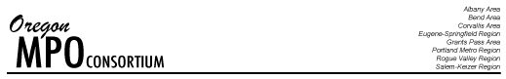

OMPOC BOARD MEETING
April 29, 2019

Bend Park and Recreation District Office
Riverbend Community Room
779 SW Columbia Street
Bend, OR 97702

8:45 Light Breakfast & Registration

9:00 Call the Meeting to Order (Craig Dirksen, OMPOC Chair)
- Introductions & Comments from the Public

9:10 Oregon Travel and Behavior Household Activity Survey (Chris Johnson)

9:55 Break

10:10 Statewide Transportation Improvement Fund Roundtable (All)

10:30 2019 Legislative Session Including Cap and Invest (Randy Tucker and Paul Thompson)

11:10 ODOT Update (Jerri Bohard, ODOT)
- Status of the director search
- Road and Bridge Condition Report/Transparency, Accountability and Performance Report and Website
- STIF funding estimate update
- Safe Routes to School program update (rapid response and non-infrastructure grants)
- Federal funding update

11:45 Working Lunch with MPO Roundtable: “Share Your Region’s Hottest Topic”

• Albany Area | • Portland Metro | • Eugene-Springfield | • Rogue Valley
• Corvallis Area | • Bend Area | • Salem-Keizer | • Middle Rogue
1:00 Walk Along the River

2:00 OMPOC Event: Discuss hosting a topical event (Craig Dirksen, All)

